Linking Exploration to Modelling

Introduction
This banking data, designed to help novice analyst link exploratory graphics to modelling results, is completely fictitious. The data contain the following fields
- End of Month Checking Balance – continuous: $1,500-$3,500
- Savings Balance – continuous: $45,000-$60,000
- Existence of Overdraft Protection – binary: yes/no
- Number of Accounts Held – classification: 1-5
- Number of Total Account Services – classification: 1-4
- Average Number of Transactions per Month – classification: 1-40
- Customer ID – unique per record
Simple and complex relationships exist between all the fields with the exception on Customer ID. We will search for these relationships using exploratory graphs and predictive models. The data will be explored using
- Dynamically linked histograms – allow you to explore how a range of values for one variable are related to other variables.
- Box plots – allow you to explore how the medians and or means of one continuous variable change with the values of a classification variable.
- Mosaic plots – allow you to graphically see percentages for a cross tabulation.
- Scatter plots – allow you to see if increases or decreases in a continuous variable are related to increases or decreases in another continuous variable.
After the exploratory analysis we will fit various data mining models to validate findings.

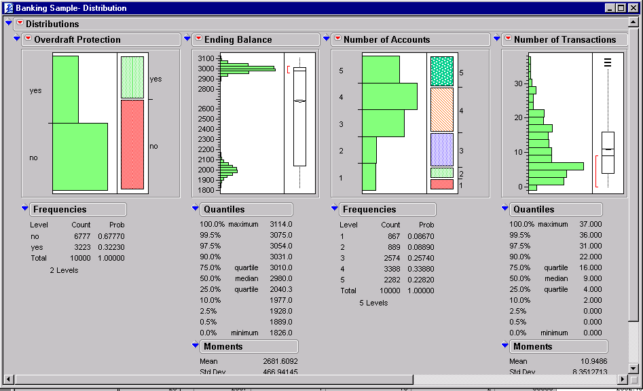
Exploring with Histograms
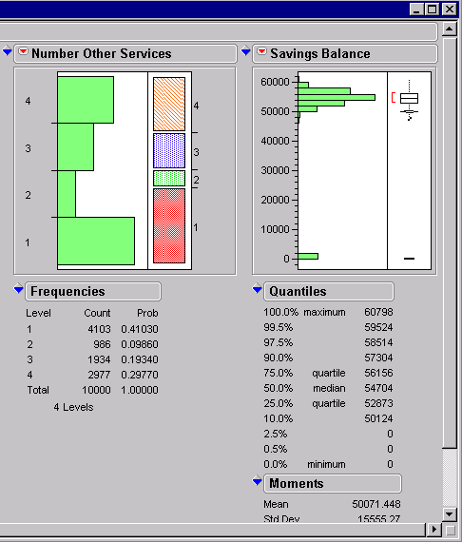
To begin, click on distribution and select all the fields except Customer ID as Y to create a histogram of each, as shown in figure 1. Or to see all the histograms on one screen run 2 distributions 1 with the first 3 columns and the second with the second 3 columns, as shown in Figures 2-6. A nice feature in JMP is all the windows are interactively linked.

Figure 1: Histogram of all Fields
Select the following areas of the histogram (subsequent figures display the results):
- Overdraft=’yes’, Figure 2
- Overdraft=’No’, Figure 3
- Low Balance, Figure 4
- High Balance, Figure 5
- Number of Accounts = “1”, Figure 6
You may wish to explore selecting areas of the accounts and services as well.

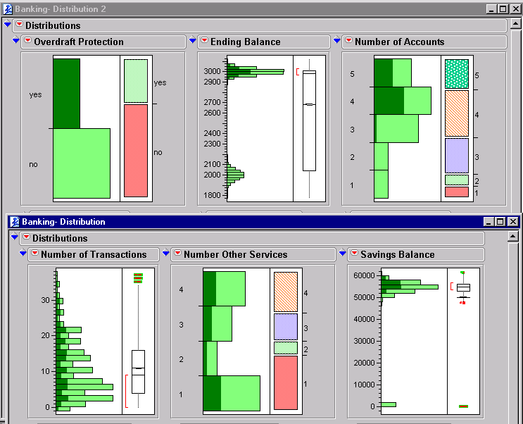

Figure 2: Overdraft related to large number of accounts, high balances

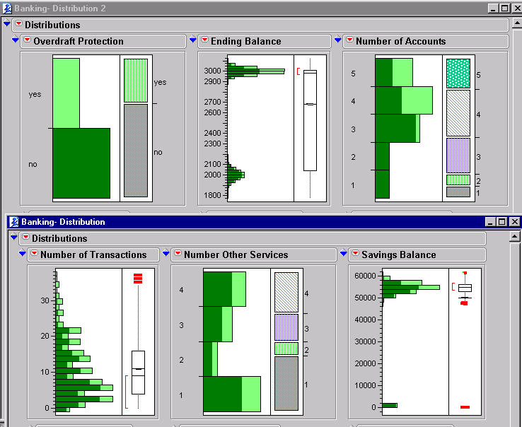

Figure 4: No Overdraft relationships are unclear
Using the brush tool and shift key, select all the low balances.
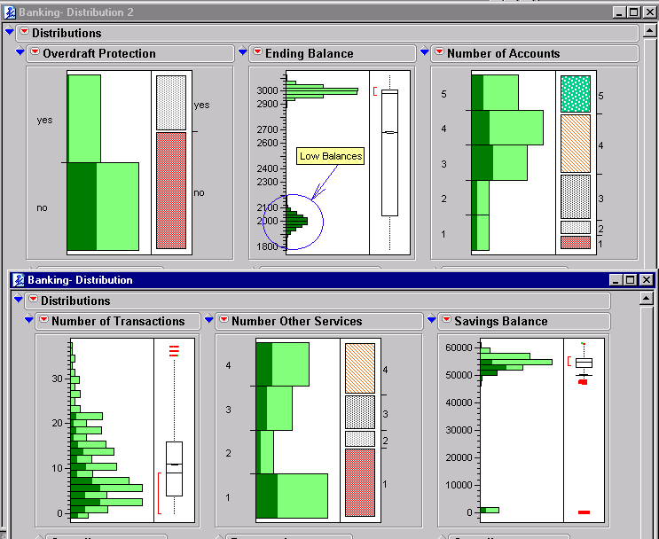

Figure 4: Low Balance related to no overdraft, low number of transactions, low savings balance

Using the brush tool and shift key, select all the high balances.
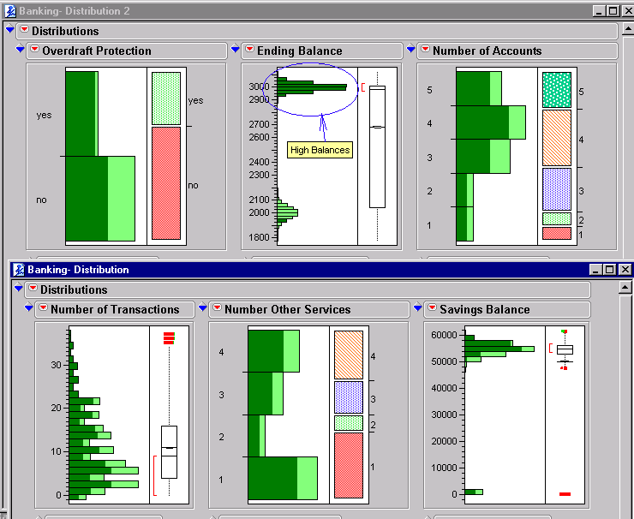
Figure 5: High Balance related to high savings balance
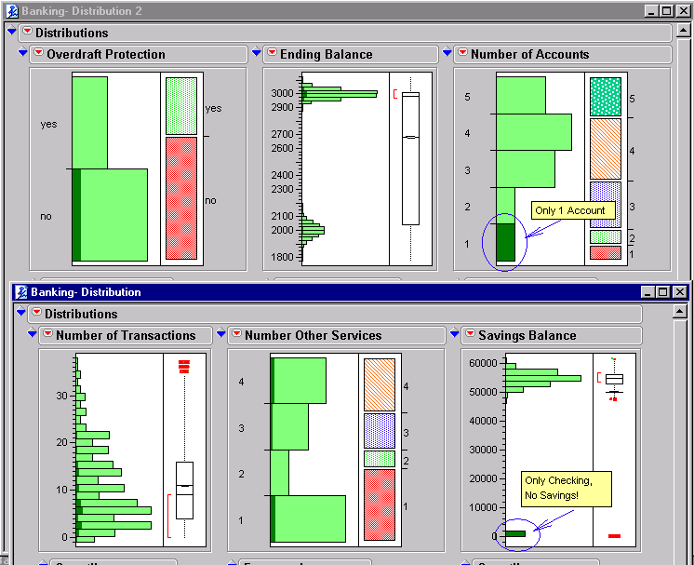
Figure 6: 1 Account is Checking, No Savings

Based on the exploratory graphics, Table 1 outlines some of the expected relationships that modelling will find.
Figure | Response (Y) | Predictor (X)
2 | Overdraft | Account
2 | Overdraft | Balances
4 | Checking Balance | Overdraft
4 | Checking Balance | Transactions
4,5 | Checking Balance | Savings Balance
6 | Savings Balance | Account

Table 1: Expected Modelling Relationships Based on Histograms

Exploring with Box & Mosaic Plots
Create the following Y*X plots adding the means for the box plots:
- Mosaic Plot for Overdraft *Accounts, Figure 7
- Mosaic Plot for Overdraft*Service, Figure 8
- Box Plot for Balance*Overdraft, Figure 9
- Box Plot for Savings Balance*Overdraft, Figure 10
- Variability Chart and Bar Chart for Balance*(Account and Overdraft), Figure 11 & 12
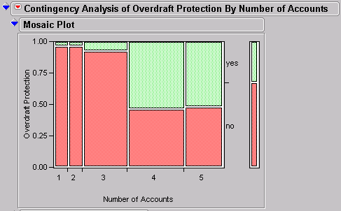
Figure 7: Mosaic for Overdraft*Accounts showing strong relationship

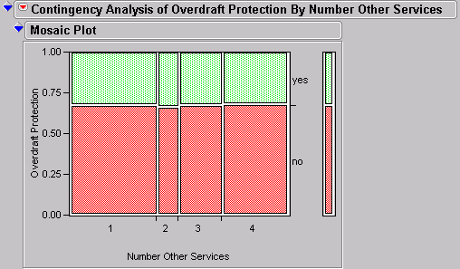
Figure 8: Mosaic for Overdraft*Services showing no relationship

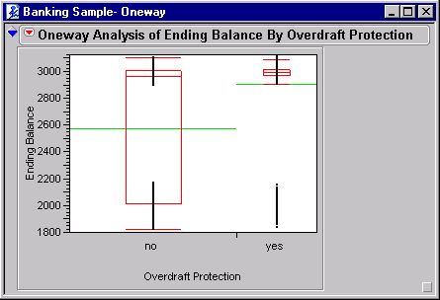
Figure 9: Box Plot for Balance*Overdraft showing strong relationship
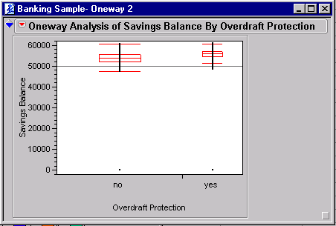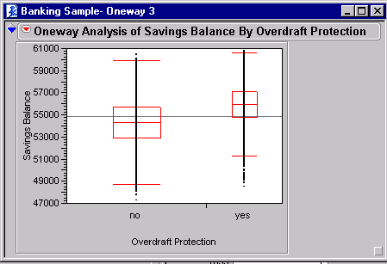
Figure 10: Box Plot for Savings Balance*Overdraft showing weak relationship

In Figure 10, the box plot on the left represents the data with the zero balances from those people who do not have a savings account only a checking account. The plot on the right represents the data with the zero values removed. You can remove the zero values by selecting the lasso tool and circling the zeros under both yes and no. Then right mouse click and select exclude, then right mouse click and select hide. Next select the red triangle next to Oneway Analysis → script → redo analysis.

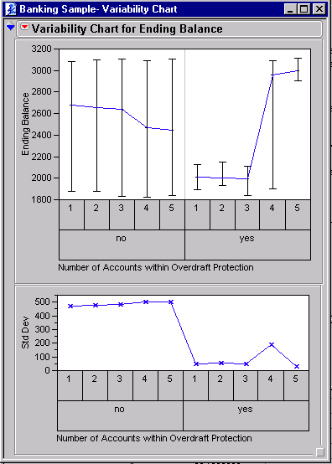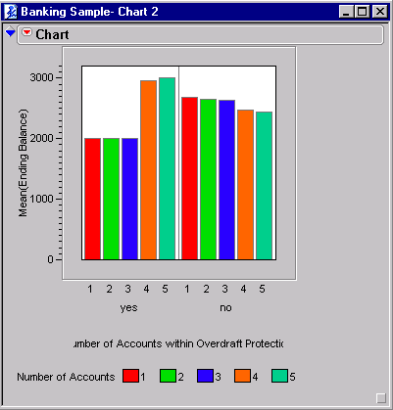
Figure 11 & 12: Variability Plot and Chart of Balance*(Accounts, Overdraft) showing interactions

Next we want to check for interactions. We can do this visually by a couple different methods as shown in Figure 11 & 12. Figure 11 is a Variability Chart of Checking Balance by Number of Accounts and Overdraft Protection. We can see in the top graph that for Overdraft Protection =”no” that number accounts = 1-3 the Checking Balance is higher than for Overdraft Protection =”yes”. The opposite is true for accounts =4 or 5. This by definition is an interaction. The bar chart is a more simplistic graph of the same information. The variability chart also shows that the variability is different for Overdraft Protection =”no” or “yes”. NOTE: You must sort the data by Number of Accounts to get the chart in the correct order.
Based on the plots, we should expect the following relationships shown in Table 2 in our models.
Figure | Response (Y) | Predictor (X)
7 | Overdraft | Account
9 | Checking Balance | Overdraft
11,12 | Checking Balance | Account by Overdraft interaction
Table 2: Expected Modelling Relationships Based on Plots

Exploring with Scatter Plots
Scatter plots are best used with multiple continuous variables. However it can be helpful to use classification variables in scatter plots. As you learn to interpret the plots you will find more and more useful ways to visualize your data.
The banking data has only two continuous variables, yet Transactions has a large number of values and could be used as a continuous variable. Change Transactions to a continuous variable then create a scatter plot (Y, Y, Y)*(X, X, X) of (Transactions, Checking Balance, Savings Balance)* (Transactions, Checking Balance, Savings Balance) as shown in figure 13. Note figure 13 also excluded the rows where Savings Balance = 0.
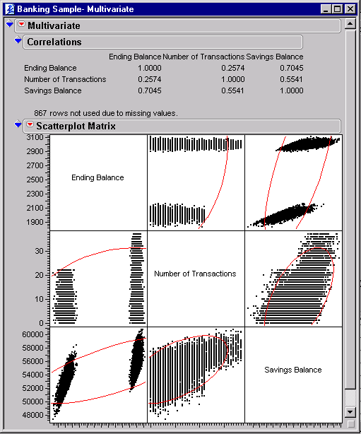
Figure 13: Scatter showing relationship of savings balance to transactions and checking balance
Based on the scatter plots, we should expect the following relationships shown in Table 3, in our models.
Figure | Response (Y) | Predictor (X)
13 | Transactions | Savings Balance
13 | Checking Balance | Savings Balance
13 | Savings Balance | Transactions
13 | Savings Balance | Checking Balance
Table 3: Expected Modelling Relationships Based on Scatter Plots

Overview of Statistical Models
JMP allows you to fit the several types of statistical models to test hypothesis about your data, or to verify suspected relationships or correlations. Table 4 provides an overview of these models.
Model | Response (Y) | Predictors (X) | Goal/Comments
Linear Regression | Continuous | Continuous | Best fit line (1X) or plane (2 or more X’s). No curvature. Relationships can be seen in scatter plots, dynamic histograms.
Polynomial Regression | Continuous | Continuous | Same as linear regression, but adds curvature.
Logistic Regression | Binary | Classification | Predict log(prob(Y=chosen value)). Similar to cross tab analysis. Relationships can be seen in mosaic plots, dynamic bar charts.
Analysis of Variance (ANOVA) | Continuous | Classification | Determines if average of response varies with values of classification variables. Relationships can be seen in box plots, dynamic histograms.
Smoothing Spline | Continuous | Continuous | Similar to regression but ‘meanders’ through the data. Can only handle one predictor. Good with a very non-linear relationship. Relationships best seen in scatter plots.
Table 4: Overview of Statistical Models
Note that none of the models in Table 4 are appropriate for non-linear data with more than one predictor (X). Combining the expected relationship tables from the visualization exercises, we can determine to appropriate modelling technique to verify relationships.
Graphic Figure | Response (Y) | Predictor (X) | Model | Model Figure
2,7 | Overdraft | Account | Logistic
2 | Overdraft | Balances | Logistic
4,9 | Checking Balance | Overdraft | ANOVA | 14
4 | Checking Balance | Transactions | Regression, Spline
4,13 | Checking Balance | Savings Balance | Regression, Spline
11,12 | Checking Balance | Account by Overdraft interaction | ANOVA with interactions | 15,16
13 | Transactions | Balances | Regression
13 | Savings Balance | Transactions | Regression | 17
13 | Savings Balance | Checking Balance | Regression, Spline | 18,19,20
Table 5: Summary of Expected Relationships based on Graphics
The following sections will fit some of these recommended models.

Fitting ANOVA Models
Fit the ANOVA (Y=X) model (Checking Balance=Overdraft) and view the results as in Figure 14.
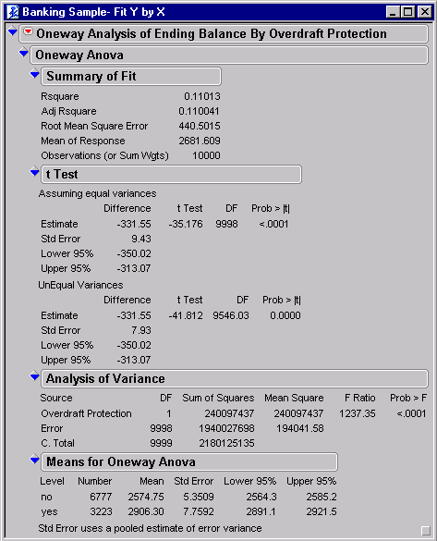
Figure 14: ANOVA showing Overdraft predicts Checking Balance
Notice the following features of the output:
- Parameter Information shows the model and the potential for three ‘parameters’ including the intercept (overall mean), overdraft=’no’, and overdraft=’yes’. The two overdraft parameters are redundant, either someone has it or they don’t, so one is removed. The status of having overdraft protection becomes the ‘default customer’ with average checking balance of $2906.
- Model Equation shows to predict the balance for a new customer you subtract $331 from the overall average for the default customer balance of $2906.
- Analysis of Variance shows the model is significantly predictive since Prob>F is 0.0001. However this could be due to the large sample we have.
These statistical techniques were designed to test known hypotheses on data collected by design. When used with large amounts of observed data, these techniques often produce very significant results. It is not so important in data mining that a variable is a statistically significant predictor, as it is important that there are strong correlations among variables meaningful to the problem at hand.

Adding Interaction Terms
Figure 15 repeats the same ANOVA adding Accounts and Accounts*Overdraft as predictors.
The Accounts*Overdraft term is called an interaction term. Interaction implies that the mean balance changes with the combined values of account and overdraft. Interactions can be difficult to see graphically, especially if several interactions exist. Some statistical modelling and data mining algorithms are very good at finding interactions.
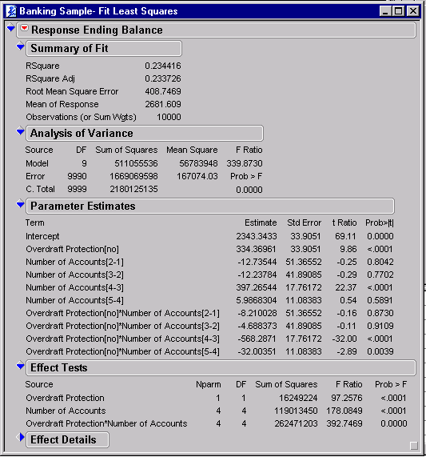
Figure 15: Interaction of Accounts and Overdraft to predict Checking Balances
Notice the following features in Figure 15:
The Effect Tests table shows multiple significant predictors: Number of Accounts, Overdraft Protection, and Overdraft Protection * Number of Accounts.
The Parameter Estimates allows us to predict checking balance for a customer by taking the overall average for the ‘default customer’ (accts=’5’, overdraft=’yes’) of $2343, subtracting $12 if the customer has one other account, adding $334 if the customer does not have overdraft protection, and subtracting $8 due to the interaction of these two factors. See Figure 16 f or actual equation. You can obtain this equation by selecting the red triangle next to Response Ending Balance → Save Columns → Prediction Formula. This adds a column to your data. Right mouse click on the new column and select Formula to see the equation in Figure 16.
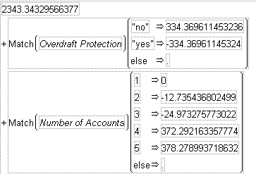
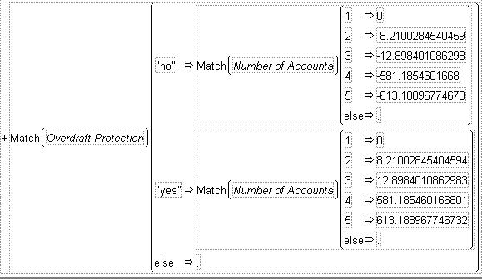
Figure 16: Equation for Interaction of Accounts and Overdraft to predict Checking Balances
Imagine how difficult it would be to determine these values from the graphics. Now, imagine that you have hundreds of predictor variables, as is often the case with data mining!

Fitting Regression and Spline Models
Fit the regression (Y=X) model (Savings Balance=Transactions) and view the results as in Figure 17. Make sure Transactions has a Interval measurement level.
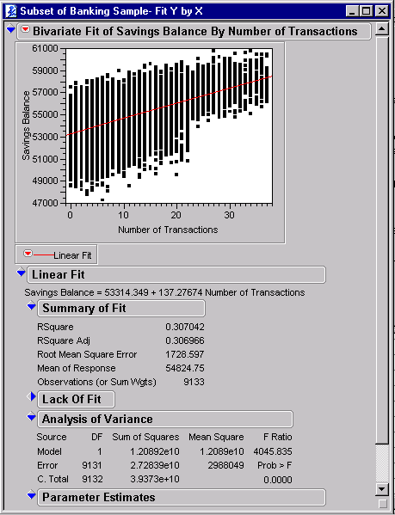
Figure 17: Regression fitting Savings Balance with Transactions
Notice the following features in the output:
- Model Equation shows that to predict savings balance for a customer you add $137 multiplied by the number of transactions per month to the overall average of $53,314.
- The plot shows the fitted line and confidence curves. The fitted line picks up the increasing trend well. Because there are so many data points in the sample, the confidence curves for the fitted line lie practically on top of the fitted line itself.
- Parametric Regression Fit shows a polynomial of degree 1 has been fit. This corresponds to fitting Y=X¹ versus Y=X².
Fit a regression model for (Savings Balance=Checking Balance). Use the red arrow options in the to specify fit a line as well as a smoothing spline lamda=100000. Figure 18 displays these models.
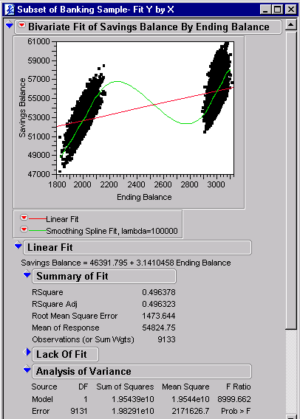
Figure 18: Regression and Smoothing Spline
Notice the following features in the output:
- The data separate into two groups because the variable Balance is bi-modal. Bi-modal means there are really two separate distributions. As a data mining exercise, you might want to create a variable that indicates the high/low status of checking balance.
- Savings balance increases with checking balance. The regression line models the increase.
- For the spline models the increases in each of the data groups, as well as the dip between them. Splines fit models on short ‘windows’ across the X variable then connect the various models to smooth the overall fit. This allows the spline to very closely follow the ‘meandering’ of the data.
- The spline model has a ‘smoothing parameter’ but no parameters related to the checking balance. Increasing the smoothing parameter allows the spline to follow the data more closely. In this sense, splines are somewhat similar to neural networks. Figure 20 shows a spline with a very high smoothing parameter. Use the slider bar to see how increasing or decreasing the ‘smoothing parameter’ changes the model.
Figure 19 shows the same model with several polynomial fit. Each increase in polynomial terms allows more curvature in the model. Note a polynomial of degree 0 calculates the overall mean.
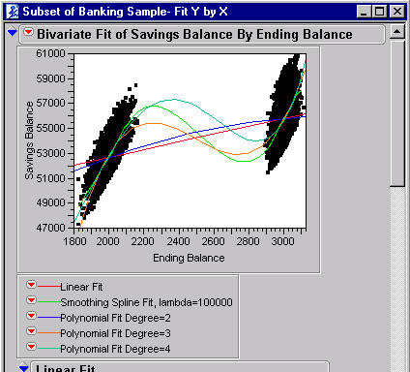
Figure 19: Polynomials of various degrees
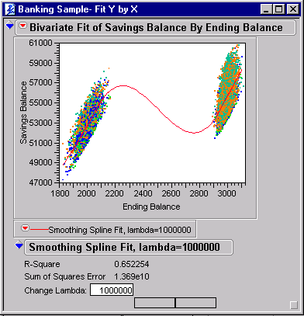
Figure 20: Spline with smoothing parameter adjusted to completely follow the data

Overview of Additional Analysis Techniques
Some other newer analysis techniques that might help us with discovering relationships in our data include
- Recursive Partition – sometimes called Decision Trees
- Neural Networks – non-linear model based
- Clustering – k-means, Hierarchical

Using default software settings, many of these techniques will provide the same or similar results to the traditional analysis we saw earlier. The user needs domain knowledge and modelling experience to create more meaningful models.

Looking at a Binary Target
Let’s first look at Overdraft Protection using Partition. Use everything except Customer ID to model Overdraft and except all defaults. Select Color to color points in the Mosaic Plot as shown in figure 22. Select Split several times to build a tree. At this point we would explore our results and decide to split or prune. Explore the results of the model. How do the results compare to what you found with visualization or the simple statistical models?

Example Rules from Decision Tree
The rules below were generated from the default decision tree. Note the tree has found the relationship between accounts, overdraft and checking balance. In addition, the tree has grouped several values of accounts and split up the range of checking balance to make the relationship more predictive.
The Mosaic Plot shows you how many cases are in Overdraft Protection =’no” and how many are in Overdraft Protection = ‘yes” and how those cases are distributed with each split in the data, as shown in Figure 21.

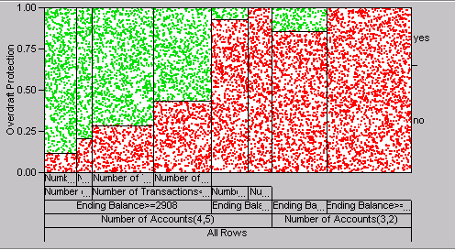
Figure 21: Mosaic Plot of Partition for Overdraft Protection

Another way to see an overall picture of the partition tree is using the small tree view. We can visually see the splits in the data . For example in Figure 22 the first split is on Number of Accounts 2&3 vs 4&5. For the Number of Accounts 2&3 the next split is on Ending Balance for Checking and the split was at $2152.

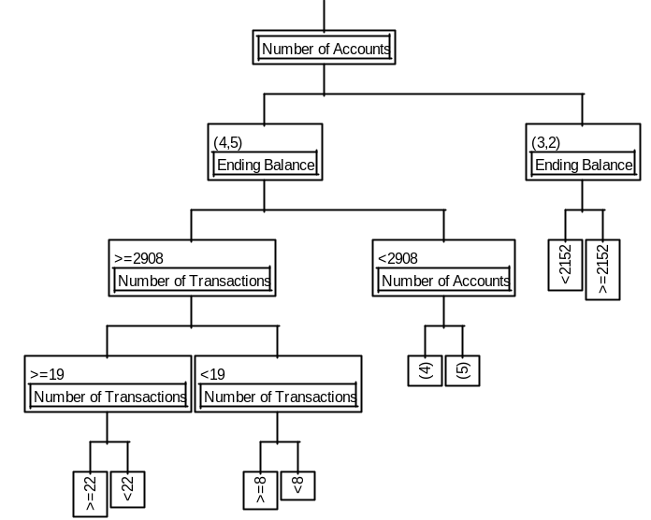
Figure 22: Tree Diagram for partition of Overdraft Protection
For a summary of the results from the partition look at the Leaf Report shown in Figure 23. The leaf report shows us that the people mostly likely (88%) to have overdraft protection of those with 4 or 5 accounts with a checking ending balance > $2908 and had 22 or more transactions. From earlier analysis we saw these relationships, but not the splitting points. Note the tree also detected the interaction of Overdraft Protection with number of accounts and checking ending balance.
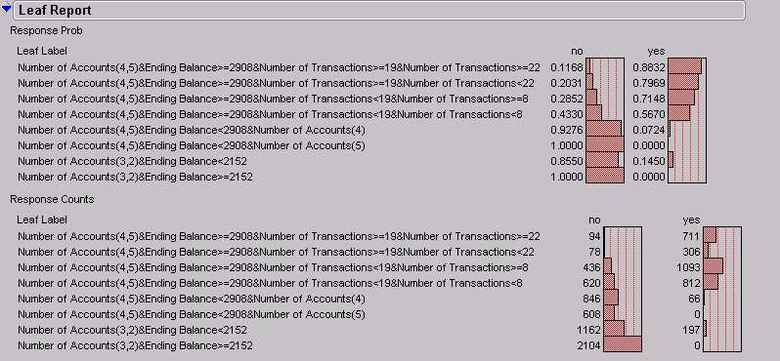
Figure 23: Leaf Report for Partition of Overdraft Protection

Modelling a Continuous Target
Use everything except Customer ID to model Savings Balance. Select Partition → Select Savings Balance as Y and everything else except Customer ID as X. Select Split multiple times to form a tree. NOTE: Before running this tree I changed Number of Services and Number of Accounts to be Continuous. This gives me a split on these variables instead of grouping 1,2 together vs 3,4 or even worse 1,3 vs 2,4 (hard to interrupt this result).

Partition Results
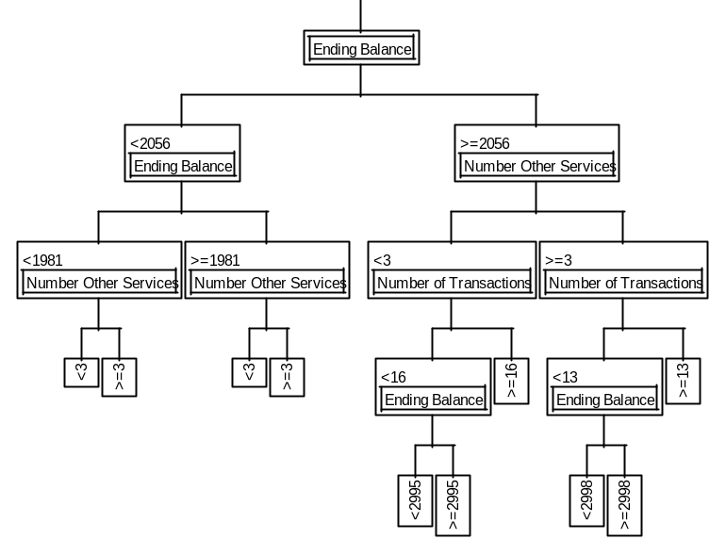
Figure 24: Tree Diagram for Partition of Savings Balance
For a summary of the results from the partition look at the Leaf Report shown in Figure 25. The leaf report shows us that the people with the highest savings balance have a checking balance greater than or equal $2,056 and the number of services greater than or equal to 3 and the number of transactions greater than or equal to 13. The lowest savings balances have a checking balance less than $1981 and number of other services less than 3. So the lower the checking balance and the less services used the less the savings balance and vice versa.
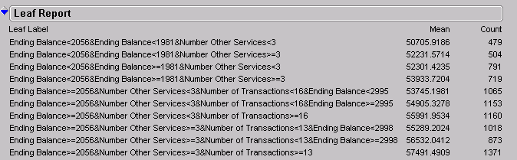
Figure 25: Leaf Report for Partition of Savings Balance
Note Savings Balance ranges from $47,000 to $60,000. Checking Balance ranges from $1,800 to $3,200.
Neural Networks

We can also use a Neural Network to model the Savings Balance. The neural network is more flexible than the previous Spline model. First select the Neural Net button, then select Savings Balance as Y and Ending Balance & Number of Transactions as X. Select OK. The Control Panel in Figure 26 will appear. The control panel allows you to select the Hidden Nodes (important number, too high can cause you to over fit, too low can cause you to under fit the model). Keep the default as 3. Next choose your over fit penalty, we excepted the default. The number of tours indicates how many models will be fitted starting at different random starting points. This is one reason Neural Nets take more CPU time. And the Max Iterations is how many iterations to run trying to reach convergence. Except all defaults and hit GO to run the model. CAUTION: This will take at least a couple of minutes depending on the speed of your computer.

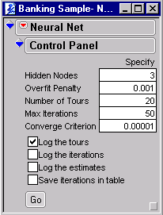
Figure 26: Neural Net Control Panel for predicting Savings Balance

When the results appear, choose the red triangle and select Diagram. The Diagram (Figure 27) shows you visually the model you have fitted using the Neural Net. Here you see our 2 inputs – ending balance & number of transactions – being fed into 3 hidden nodes to predict the savings balance.
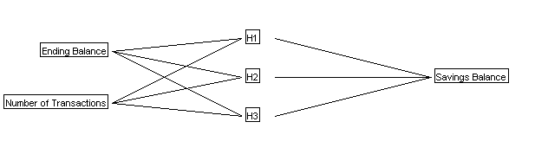
Figure 27: Diagram of Neural Net to predict Savings Balance

The results from the Neural Network are shown in Figure 28. You can see that 4 of the 20 tours converged at Best, 10 failed to improve and 6 reach Max Iteration. If you click on the blue triangle next to the Parameter Estimates you can see the estimates for each of the hidden nodes for each parameter. One of the reasons the neural network takes a little while to run is because it is creating multiple parameter estimates for each input variable (i.e. if you have 3 hidden nodes and 2 inputs then 6 parameters are being estimated + 3 intercepts for each hidden unit). You can also look at plots of Actual by Predicted and Residual by Predicted. In figure 28 you can see from our Actual by Predicted plot that we have a pretty good fit for Savings Balance.
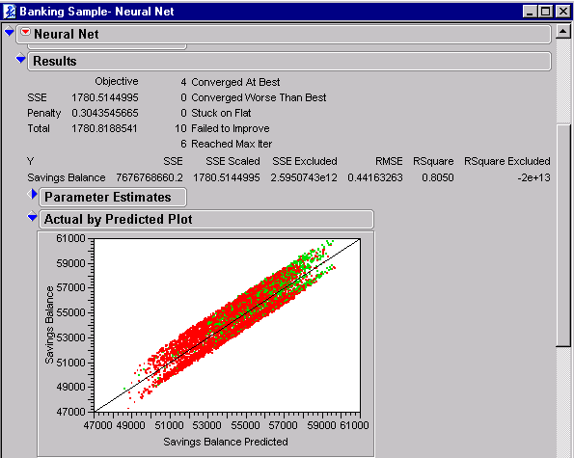
Figure 28: Neural Network Results for predicting Savings Balance

One of the nice features of Neural Networks is the Contour Profiler. Click on the red triangle next to Neural Net and select Contour Profiler. Here you can see a 3 dimensional plot of your data. This gives you a nice representation of the shape of your data distribution. Using the hand tool you can rotate the plot to see it from any angle. You can also interact with this plot by using the slider bars above. The graph to the left is a cross-sectional plot of the data (ie slice the 3 dimensional plot and see what that 2 dimensional slice looks like.)
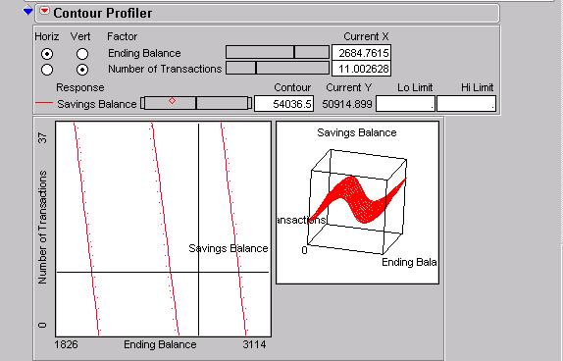
Figure 29: Visual Graphic of surface being predicted for Savings Balance

Clustering
Clustering is used to see what observations; in this case bank customers are most similar. Choose Multivariate tab from the JMP starter, then choose the k-means cluster button. Select all your continuous columns as Y (NOTE: Change Number of Accounts and Number of Other Services to continuous before running this analysis to get the same results). You are then brought into the control panel. Here you can choose how many clusters you want, as well as, other options. We will stay with the defaults. Hit Go. You will see the results as they iterate on your screen (Figure 31). When the iterations are complete you can look at the biplot (Figure 30), by selecting the red triangle → biplot. If you choose biplot before hitting GO you can watch how the clusters change with each iteration. Now with 3 distinct clusters we may want to model separately on each cluster. Looking at the results (Figure 31) it appears that the clusters are based on level of value to the bank (ie high balances, high # of accounts, high # of transactions, high services vs med and low.) From a practical standpoint we might want to market to these clusters differently.

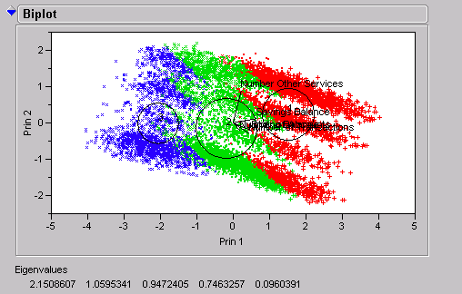
Figure 30: Biplot for K-means clusters of Banking data.

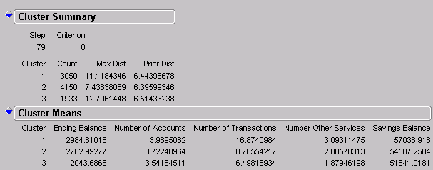
Figure 31: Results from k-means cluster analysis on Banking data

Back to the Start
To complete the link between visualization, statistical models and newer analysis techniques, we have added suggested mining models to use for finding the expected relationships uncovered during visualization. Try setting up these models and exploring the results.
Graphic Figure | Response (Y) | Predictor (X) | Statistical Model | Mining Model
3,9 | Overdraft | Account | Logistic | Logistic, Tree
3 | Overdraft | Balances | Logistic | Logistic, Tree
5,11 | Checking Balance | Overdraft | ANOVA | Regression, Tree
5 | Checking Balance | Transactions | Regression, Spline | Regression, Tree, NN
5,6,14 | Checking Balance | Savings Balance | Regression, Spline | Regression, Tree, NN
13 | Checking Balance | Account by Overdraft interaction | ANOVA with interactions | Tree
7 | Transactions | Accounts | ANOVA | Tree
7,14 | Transactions | Balances | Regression | Regression, NN, Tree
14 | Savings Balance | Transactions | Regression | Regression, Tree, NN
14 | Savings Balance | Checking Balance | Regression, Spline | Regression, Tree, NN
Table 7: Suggested Statistical and Mining Models

